An incentive strategy to address Sustainability Concerns in the Implementation of a Successful Renewable Water Bottle Campaign"

# Background and objectives

Despite it being a well-established fact that single-use plastics pose a significant threat to the environment, we’ve observed that our community doesn’t seem to be concerned with this fact nor is bothering to change their lifestyles to mitigate this issue.

Our aim is to make it more worthwhile for students to adopt the use of reusable water bottles, tackling both issues of forgettability and inconvenience to address the issue of unsustainability within our community.

Through this campaign, we hope to contribute positively to the reduction of single-use plastics within Temasek Polytechnic in the long-term; Through this, we hope to cultivate the development of a more sustainable and environmentally responsible community.

# Hypothesis

‘Students in Temasek Polytechnic are not consistently bringing reusable water bottles to school due to minor issues.

# Methodology used and results obtained

After conducting an online survey across all six schools using Google Forms, we managed to gather a sample size of 72 to answer our initial hypothesis.

The data from our survey not only affirm the existence of this issue, but opened an opportunity for us to narrow our hypothesis down to two primary factors affecting this issue:

1. **Convenience**: A sizable percentage of respondents said that bringing their own water bottles to school is inconvenient.
   1. The bottle's size, weight, or difficulties fitting into their bags are factors that can be considered.
2. **Forgetfulness**: Students often forget to bring their own water bottles from home.

We have created a visual representation to help highlight these findings, as shown in *Figure 1* below:

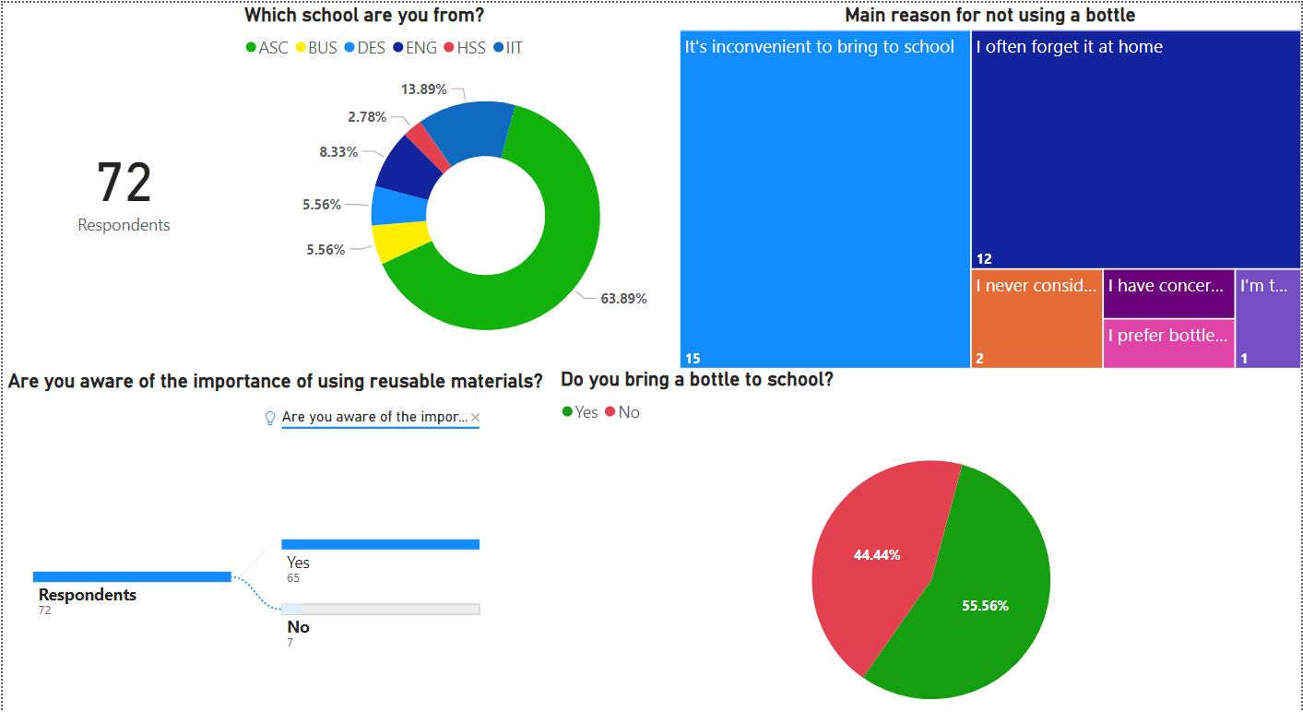

Figure 1 – Dashboard made with PowerBi

These findings reveal that despite 90% of students being aware of the importance of using reusable materials over unsustainable one-time use plastic, 44% of students still do not bring a reusable bottle to school and must rely on single-use plastic bottles. Based on the data, there are 2 main causes that deter these students from using a reusable bottle, and if we could solve these two issues, we are confident that this could lead to a greater percentage of students bringing their reusable bottles to school.

# Discussion

“How do we improve students' commitment to using reusable water bottles?”

Idea #1: Award students SEAL points for their consistent commitment in bringing a water bottle to school. If a student brings a bottle for 85% of the school semester, they will be awarded SEAL points. Here’s how we plan to track their usage:

* 1. **QR code attendance taking**

A QR code could be included near a few water coolers in the school for a few months to determine the efficacy of the program. Students can scan the QR code after filling up their water bottles to log their attendance into a form. The form will require students to submit an image of themselves holding their water bottles and will only accept 1 entry per day from a single device, this is to cap the maximum amount of participation for an individual to minimize exploitation. Students are required to resubmit an image every few days to maintain their attendance record.

QR code redirecting to campaign form

To verify attendance and to further reduce the risk of exploitation, the data collected from this form will be processed using an Artificial Intelligence (AI) model. The training phase will involve collecting the facial data of all willing participants during our first trial of the campaign, using the photos they submit for attendance. An existing AI program designed to extract and identify faces from photos will be utilized.

Alternatively, if the opportunity presents itself, we hope to collaborate with Temasek Polytechnic to incorporate their student information database into the AI model for a faster and more accurate identification of faces.

The virtually automated data-processing phase is projected to proceed in the following manner:

1. All records where students have selected "I do not consent" are excluded from record taking.
2. A case-insensitive comparison to match the school email with the admin number submitted will be subsequently performed. If the admin number does not align with the email's admin number, the respective record is removed from the dataset.
3. To ensure that only one record per day is retained, a random sampling procedure will be applied. This should effectively filter out duplicate submissions made by a student on the same day.
4. Once the data has been cleaned, all images uploaded will be subject to an AI Image Classification Recognition System. This system scans each selfie to identify the presence of a face and a reusable water bottle. If the system fails to detect both objects, the record is deleted, and no attendance is awarded for the admin. number tied to the submission.
5. If it is confirmed that the uploaded image contains a legitimate face and a reusable water bottle, the AI system will then proceed to match the face with the student's face stored in Temasek Polytechnic's student database to confirm their identity with their inputted information.
6. The system will also check for any suspicious behavior, such as students frequently changing their water bottles or multiple students possessing nearly identical bottles, especially within the same class, are flagged as needing further review. Similarly, difficult to identify uploads are also flagged for review. These flagged records undergo manual approval by moderators on a case-by-case basis.
7. If exploitation or multiple instances of a breach of terms is identified, the student will be blacklisted, resulting in the deletion of all their records from the system, making them ineligible for the SEAL points award.
8. Once the semester ends, *Microsoft Excel* will be utilized by moderators to collate and identify students with an 85% or higher track record and subsequently award them the promised SEAL points.

# Conclusion

We believe that this program will prove itself effective in achieving our goals of cutting down on single-use plastics within Temasek Polytechnic. The rationale is that students without reusable bottles on hand would not bother themselves with a visit to a water cooler, and those with reusable bottles would already be frequenting water coolers.

Furthermore, those who don’t already use reusable water bottles for the reasons of ‘forgetfulness’ and ‘inconvenience’ will now have a reason to remember and bring their water bottles to school: SEAL points. This incentivizes an environmentally sustainable behavior through the prospect of SEAL points.

System abuse, while possible, is highly unlikely due to the implementation of ‘photo-taking’, which would render tactics intended to abuse the campaign such as unlawful lending or unfulfilled criteria, effectively more bothersome to set in motion. We believe this as the images students would be required to submit would allow us to confirm any suspicious behavior and recognize abnormal trends amongst students who bring supposedly bring ‘their own bottles’. Such submissions could include trends such as a student having a different bottle every day or submitting an irrelevant photo to clock-in their attendance despite not having a bottle, which would easily be detected and removed by the AI model.